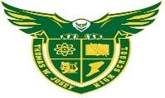



T
S O A R  R | WE CAN BE | CLASSROOM | CAFETERIA | NON-  CLASSROOM | BATHROOM | HALLWAYS
 |   SCHOLARLY | - Be in your seat before the bell  - Complete all assignments  - Take ownership of your learning  - Use cellphones for instruction only | - Select healthy food options  - Read the nutrition labels  - Attend your scheduled lunch period only | - Refrain from wearing headgear such as caps, wave caps, ski-masks, hoods, beanies; etc in the halls  - Keep pants pulled up. | - Wash and dry your hands  - Clean up after yourself | - Refrain from wearing Earbuds/ Head phones  - Walk on the right side of the hall  - Refrain from using cellphones
 | 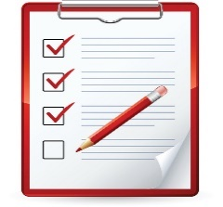  ORGANIZED | - Keep your belongings and materials neatly where they belong  - Keep your desk and work area clean | - Depose of food in the proper manner  - Line immediately to get your lunch | ☞ Keep all materials with you   Have a school issued hall pass at all times  - Keep your locker clean.  T.W. Josey High School | ☞ Have a hall pass when using the restroom during class | - Gather all materials during class changes  - Report to your assigned class on time with all of your supplies
 | 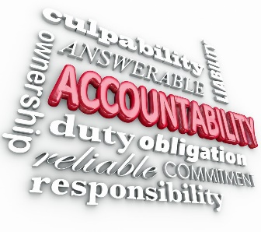  ACCOUNTABLE | - Turn in all missing assignments  - Work cooperatively with your classmates  - Check Infinite Campus and Canvas for your assignments | - Listen to the directions of staff members  - Keep your space  and table clean  - Offer to help others  - Remember your much id number | - Follow Dress code  - Refrain from wearing ear-  buds and earphones  - Refrain from cellphone usage  - Keep your locker locked. | - Properly  discard of trash  - Return to your classroom promptly | - Move to class within the allotted time  - Have a school issued hall pass anytime you are in the hall  - Passes are not  issued the first and last 15 mins of class (15/15 rule), take care of your business between classes
 | 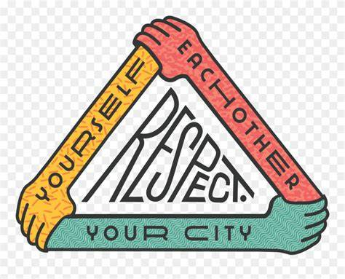  RESPECTFUL | - Use non-offensive language  - Use material appropriately  - Respect peers, teachers and classroom guests | - Listen to the direction of staff members  - Use an inside voice  - Practice good table manners  - Refrain from throwing food items | - Be positive  - Use non-  offensive language and appropriate volume | - Knock before  you enter the  stalls  - Flush the toilet when you are finished | - Use non-  offensive language and appropriate and appropriate vocabulary  - Keep hallways  quiet during classes

